PAPERS

TITLE:

DIGITAL NATIVE USERS GROWT

IN INDONESIAN LIBRARY

WRITER:

HENDRIKUS FRANZ JOSEF, M.Si



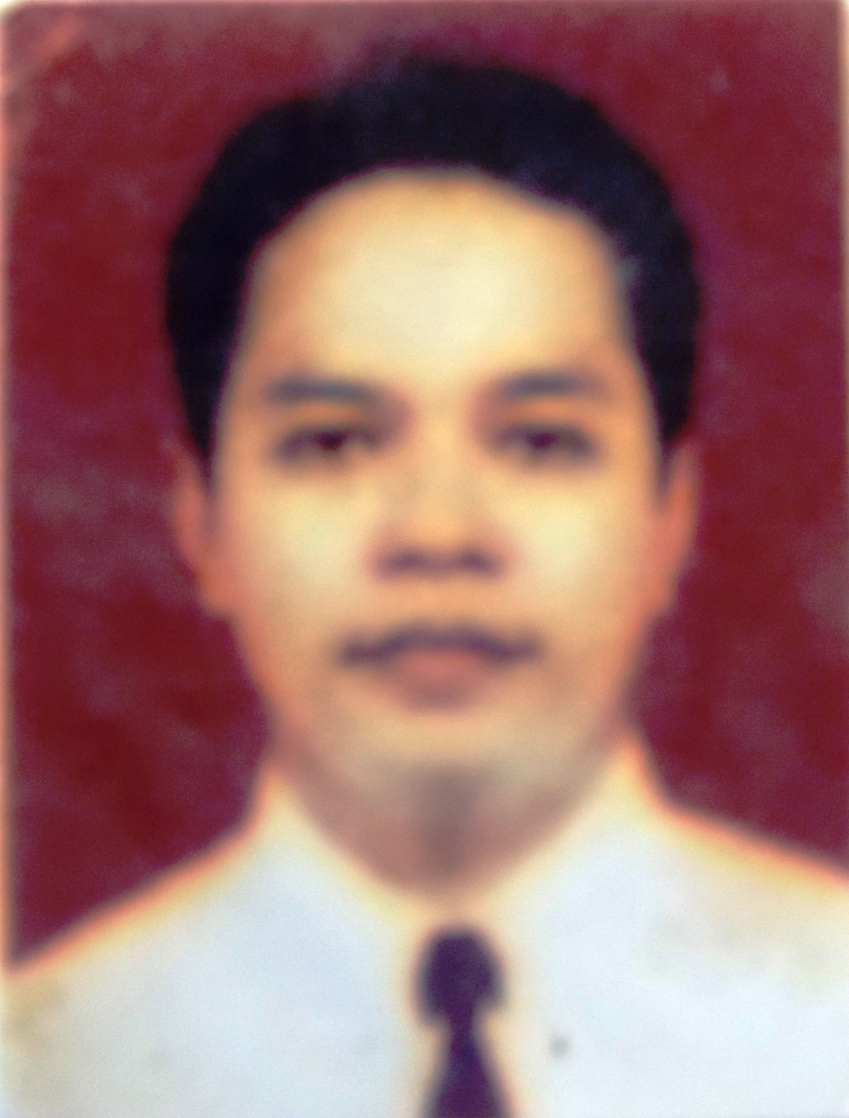

THE BOARD OF LIBRARY AND ARCHIVE OF YOGYAKARTA SPECIAL REGION

INDONESIA
2017

Statement Letter

Yogyakarta, July 10, 2017

By this letter I state:

Name | : Hendrikus Franz Josef, M.Si
Profession | : Librarian
Rank / Group | : Penata/ III c
Employee ID number | : 197508222005011009
Institution | : The Board of Library and Archive of Yogyakarta Special Region

States that this paper is my own work and does not contain plagiarism. Here is the results of anti plagiarism detection from www.smallseotools.com/plagiarism-checker, is 100% unique, which means there is no element of plagiarism.
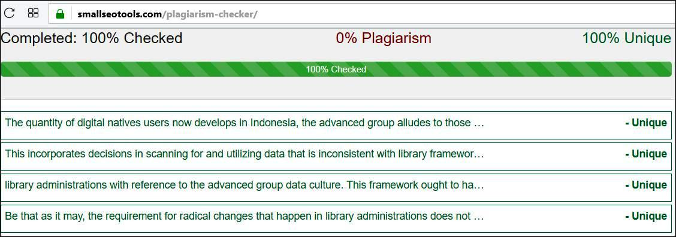

Thus I make this statement to be used properly.
Signed Author / Librarian

Hendrikus Franz Josef, M.Si
NIP. 197508222005011009

Abstract

The quantity of digital natives users now develops in Indonesia, the advanced group alludes to those conceived in 1995 and past. They live in a world of advanced innovation focused on the web, have their own 'dialect' and manufacture an alternate character from their folks. This incorporates decisions in scanning for and utilizing data that is inconsistent with library frameworks worked with the old attitude in the simple world. Since they can never again be precluded to be part from securing the development of library clients, bookkeepers ought to be more innovative in rolling out improvements to existing library administrations with reference to the advanced group data culture. This framework ought to have the capacity to go past simply digitizing data sources and library indexes. Bookkeepers working in the Internet condition are always in contact with mechanical space that is unpredictable, offering radical new and potential methods for imparting, giving and deciphering data/learning and autonomy. Be that as it may, the requirement for radical changes that happen in library administrations does not mean surrendering clients who don't yet have the capacity in the advanced field. Bookkeepers at present face the test of building up the administrations gave to the computerized group while holding the current ones for those new to the advanced world and additionally guiding the issue to the administrator himself.

Introduction

At first, it was Marc Prensky in 2001 that presented the expressions "digital natives" and

"digital immigrants". As he make, " digital natives " are individuals naturally introduced to a world that is as of now stacked with computerized innovation and - hence - they are exceptionally articulate utilizing the innovation. While "digital immigrants" or "computerized transients" are individuals who are naturally introduced to a still simple world however then develop in an advanced situation. Like migrants who must adjust to various societies in their new nation, computerized participants must adjust to the diverse societies of the advanced locals.

However, outsiders will remain foreigners, as per Prensky. They might be familiar with the local dialect however the first emphasize stays intrinsic. They might have the capacity to adjust indigenous societies and traditions in social life, yet their usual ranges of familiarity stay comparable to. They might have the capacity to fill in and also locals, however with the intrinsic personality and qualities ​​of the universe of starting point. Advanced participants won't be extremely similar to digital natives and feel great in the computerized world. They won't have the capacity to relinquish every one of the propensities, qualities, and attitude framed by the simple world. Advanced vagrant instructors for instance. They brought the simple into a digital natives indigenous class. The educator's agreeable zone is the simple zone. The agreeable zone of his understudies, the computerized zone. The showing framework based on simple standards is connected to understudies with advanced ideal models. This worldview contrast in instructing and learning exercises is associated to be the reason with the declining nature of training in the United States.

As indicated by Toledo, digital natives are digital innovation clients matured 30 years or less. While digital immigrants are clients of digital innovation matured 30 years or more (Toledo, 2007). This strategy depends on the presumption that individuals conceived 30 years prior or later, naturally introduced to a world where digital innovation is as of now part of life of many individuals. Then again, individuals conceived over 30 years back naturally introduced to a world where digital innovation has not entered the joints of individuals' lives. On the off chance that tallied 30 years before 2005 when the above refinement is distributed, at that point digital immigrantsare those conceived previously 1975. While those conceived from that point are digital natives. While Palfrey and Gasser called the 1980 as the digital indigenous division of digital immigrants.

Be that as it may, it ought to be recalled that building up a year as the start of the introduction of digital natves populace as above isn't for the most part pertinent to all nations. Entrance of digital innovation in the public eye does not happen around the same time in all parts of the world. By and large, digital innovation initially happens in created nations than in creating nations. Entrance of digital innovation happens first in the United States than in Indonesia. Moreover, one must understand that one doesn't really turn into a digital local just on the grounds that he was conceived in America after 1975. Interestingly, one isn't really a digital guest since he was conceived in 1975 or earlier (Slyke).

CHAPTER I

Penetration of the Use of Information Technology

What is implied by computerized innovation are altogether parallel based innovation. In particular an innovation that uses the estimation of zero digits and one to bring the flag or data as in advanced TV for instance. Additionally on computer games, camcorders, music players, smartphones, tablets and PCs. The Internet is unmistakably computerized innovation. When all is said in done, "advanced" alludes to advances that include, or identify with, PC innovation. The predominance of the utilization of computerized advancements in a nation winds up noticeably one of the contemplations to decide the birth year of the nation's first advanced indigenous populace. Another necessity is, the planned innovation has entered the lives of numerous gatherings of people and is utilized intelligently between clients with each other.
The commonness of the utilization of intelligent digital innovation is an essential for the arrangement of another culture that turns into a digital native marker. Culture is the aftereffect of human collaboration. Digital native as a gathering with its own way of life is the aftereffect of cooperation between digital innovation clients. Subsequently, "association" turns into a critical essential for the arrangement of digital natives. Digital contraptions, for example, digital cameras, digital music players, and tablets autonomously don't make another culture that recognizes the digital native from the non. They are just piece of the development of the digital native as a culture as a result of collaboration between its clients. The communication utilizes a digital holder called the Internet. The Internet is turning into a focal instrument in the development of a native digital populace. Hence, the commonness of Internet utilization (Internet infiltration) is the fundamental pointer in deciding the time of the introduction of the digital indigenous populace, in different nations and in Indonesia.
A few individuals from the novice radio group in Indonesia figured out how to interface the novice system of Bulletin Board System (BBS) in 1986-1987 which is a system of "email store and foreward" with the goal that email association between novice BBS servers around the globe can run easily. This can be viewed as the start of Internet entrance in Indonesia, however it can not yet be the reason for deciding the birth year of the local advanced populace in the nation. Since the utilization of the Internet around then a large portion of the is additionally initiators. Some are individuals from the starting group. The quantity of Internet clients around then was little and constrained to exceptional groups. Its usefulness is likewise constrained to email.
The quantity of Internet clients in Indonesia started to become after the foundation of Indonesia's first business Internet Service Provider (ISP), Indonet, in 1994. Indonet gives chances to the overall population to associate with the Internet. Access to the Internet is along these lines never again limited to particular groups. In 2017, eMarketer estimates netter Indonesia will reach 112 million people, beating Japan in the fifth rank of the growing number of Internet users more slowly. Overall, the number of internet users worldwide is projected to reach 3 billion people by 2015. Three years later, by 2018, an estimated 3.6 billion people on Earth will access the internet at least once every month (https://kominfo.go.id/content/detail/4286/pengguna-internet-indonesia-nomor-enam-dunia/0/sorotan_media).
In addition to the quickly growing number of clients, the functionality of the Internet likewise extends beyond the function of electronic mail. Personal sites have sprung up following the simplicity of hosting and making the landing page. Following then online journals, Face Book, and other web-based social networking that permit interaction between audio-visual interaction. Skype encourages their audio-visual interaction progressively. It's tied in with being an advanced indigenous population with many nicknames: "N-geners," "Webheads," "Keyboard Kids," "CyberChildren," and "the MySpace Generation." and booming internet bistro generation in Indonesia. They lead the journey into unlimited virtual world domain, passionately embracing the Internet yet and advanced items from computer games to smartphones to Ipod (Montgomery). They live with the Internet and computerized contraptions.
In 1995 was the time of the start of the developing number of Internet clients in Indonesia. They utilize the Internet for different purposes. To send electronic mail, to learn, to work, to play recreations, to companions, and for different purposes. In them at that point develop the propensities shaped by computerized innovation. New propensities are not the same as the propensities for guardians, their uncles and close relatives who were conceived in the simple time. They are indigenous Indonesian advanced, hypothetically conceived at the latest 1995 and extremely familiar and regularly use different computerized innovations. Their ancestors were populaces conceived before 1995, some of them endeavoring to embrace computerized innovation and some stay in analog technology.

CHAPTER II

The Difference of the Generation of Information Technology Users

The terms Digital Natives and Digital Immigrants were made by an instructive expert named Marc Prensky in 2001 in his Digital Natives, Digital Immigrants. Marc examines the hole between the Students who were conceived as Digital Natives in the most recent decade of the twentieth century. With Educators who utilize the old technique to instruct their understudies. Since he supposes innovation has changed the way understudies think and process data. So it is troublesome for Students to exceed expectations scholastically utilizing instructing techniques that are obsolete (artifact). Prensky nicknamed these youngsters Digital Natives as "Local Digital".
Age Digital Natives is an age conceived where innovation is as of now in its condition (beginning in 1990). While the age of Digital Immigrants is an age conceived before 1990. Actually I feel fortunate on the grounds that incorporated into the transitional age. Since regardless I get childhood by guardians who still utilize customary accents in instructing me. So the Digital Immigrants complement is as yet joined to me. For instance I would preferably read a print book than perusing an electronic book utilizing a PC, or I'd preferably meet and examine something than talk about it in a visit gathering, or I'd preferably go to the market than purchase something on the web. What's more, it truly encourages me in getting along and associating as I grow up.
Be that as it may, after the year 2000 alongside innovative advances and infiltration of the undeniably huge Smartphone, kids today are extremely Digital Natives. So it wound up plainly ordinary that the present kids conceived after 2000 are capable to work Smartphone before the age of 3 years. Some view this as incredible. Be that as it may, how about we witness why this can? This happens on the grounds that since adolescence innovation has been in the earth. How do guardians bring pictures with Smartphones, welcome selfie, how his folks answer to Whatsapp messages, engage him with vidio on youtube and others. God help us, even while still in the womb the infant feels that the mother's finger is continually moving nimble on the touch screen Smartphone. Conduct is he recorded constantly so in a roundabout way the kid knows about innovation, on the grounds that the innovation is in the earth. This is the genuine age of Digital Natives. Here's an amusing vidio of Digital Natives age.
One doesn't really turn into a digital native essentially on the grounds that he was naturally introduced to the digital world. On the other hand, a man naturally introduced to a simple world isn't really a digital contestant (VanSlyke). The ability, capacity, and accessibility of digital innovation are the supporting components of a man turning into a digital native or not (digital devide). Accordingly, the utilization of the expression "populace" here is more proper than "age". "Age" alludes more to the balance of the birth time frame, (for example, "baby boomers") while "populace" contains the quantitative importance of a gathering with trademark similitudes.
Prensky, as of now specified, compares digital contestants as workers who must figure out how to ace their new dialect. They may well be the familiar speakers of that dialect.
Be that as it may, as outsiders they won't have the capacity to free themselves from their first language. They may be native simple speakers of simple dialect. Furthermore, this as indicated by Prensky shows digital contestants won't be as familiar as digital natives in utilizing digital innovation. This similarity isn't exactly right. Less exact in light of the fact that the adequacy of dialect account in correspondence isn't altogether subject to the highlight. Also, not a couple of speakers of outside dialects ​​are as vocal and dialect talk the first language (VanSlyke).
Besides, regardless of whether digital contestants talk digital and simple digital dialects, digital participants don't really have an indistinguishable vernacular of digital indigenous lingo from they turn out to be a piece of, and live digital lives as a digital native. Notwithstanding the advantages and disadvantages of digitizing digital participants from digital natives at the level of ideas and hypotheses, Prensky on the down to earth level has drawn the consciousness of the need to recognize the progressions that happen because of the boundless of digital innovation in the public arena. The spread has shaped another culture or propensity that is not quite the same as the way of life or traditions of digital participants. Indeed, even the physiology of the digital native brain developed to be not the same as the physiology of digital immigrants.
Late research in the field of neurobiology demonstrates that the structure of the mind creates as indicated by the sort of stimulant it gets. The change endures forever. The cerebrum can, and continually change as indicated by the info it gets a marvel called neuroplasticity (Prensky, II). About the contrast between digital immigrant and digital natives, Toledo clarifies the patterns amongst educators and their understudies. Instructors speak to a populace of digital transients while understudies speak to the local digital populace. The conclusion is that the propensities and methods for educating digital vagrant educators don't fit with the propensities and methods for learning of digital local understudies (Toledo). The opposing nature or propensity between digital contestants (educators) and digital natives (students) is firmly associated to have decayed the quality with instruction.
Notwithstanding the method for educating isn't great, how to take in the instructors are likewise portrayed by digital immigrant. Despite the fact that they appear to learn digital innovation by learning digital natives, as a result they apply simple approach. The aftereffects of an investigation demonstrate that instructors of the digital immigrant age have a tendency to learn while honing and trying different things with digital innovation in a community and intuitive social condition. Not in singular confinement. The distinction is, the educators learn intuitively and cooperatively in an environment of up close and personal. Not through the system (Internet) as the digital natives. Besides, the investigation found that digital immigrants (educators), like most digital immigrants, think about digital innovation for their survival in new situations, the digital condition (Senjov-Makohon).
Digital natives won conceived in the digital field. They develop in a digital situation. In them develop the qualities and slants that are good with digital innovation, for example, multi-entrusting. They have a tendency to learn bunches in systems administration. They have a tendency to use an assortment of sound and video media and pictures other than content as a wellspring of data about a similar thing. The way they read they tend not to be direct but rather to bounce around following hyper connects on a perusing base. They have a tendency to learn in gatherings, associated with each other through the Internet.
The distinction in nature between digital natives and digital immigrants isn't simply a conduct in the pursuit and utilization of data like the above passage. The simplicity of scattering data rapidly and generally through the Internet, joined with imaginative incitement by the system, has influenced digital natives to think less about protected innovation rights. For them, sharing data is only an ideals and downloading tunes from the Internet is a simple fortunes that does not have to think about parts of copyright. The capturing of works by digital immigrants has been stayed away from, or "compelled to do" covertly, for digital natives are typical.
In the mean time, the simplicity of making and spreading the outcomes through the Internet has developed the idea of thinking little of inventiveness. Quality control through strategies regarded standard by digital immigrants, however thought to be just an exercise in futility by digital natives (Palfrey and Gasser). For digital immigrant, time is of the embodiment of value. Because of keeping, acquiring data instantly is no more terrible than getting definitive data not quickly. That is a piece of the normal for digital natives, which is a logical inconsistency to the qualities of digital participants. Such logical inconsistencies propose a jumble between digital natives and digital immigrants from numerous points of view, incorporating into terms of inquiry propensities and data usage. This guide infers the requirement for a digital immigrant bookkeeper to tailor the work to the attributes of users and librarians of the digital natives.
Most Indonesian administrators today are digital immigrants, and some are digital natives. While clients of libraries in Indonesia, some have digital natives and some are as yet digital outsider. This reality conveys two ramifications. To start with, the likelihood of a potential worldview hole that could possibly refereeing between a senior custodian who is a digital migrant with a lesser administrator who genuinely digital natives. Furthermore, there is a hole between simple library based memberships with digital natives clients as far as seeking and utilizing data.
The primary ramifications, the worldview hole between librarian of various populaces (digital immigrants and digital natives), is internal. Struggle that may emerge from the worldview hole will be terrible for the library work process. To keep this from happening, administrators from the digital migrant populace must comprehend the librarian' insight of the digital natives populace to in this manner stifle the negative-affecting and empowering properties that decidedly influence librarianship. From various digital local characteristics portrayed by Palfrey and Gasser, the most affecting properties of libraries are the issues of personality disguise (the web), security (data), protection issues, nature of trailblazers, and activists, notwithstanding the said quality and theft issues .

CONCLUSION

The number of inhabitants in digital natives in Indonesia is getting progressively and developing quick. They moved toward becoming custodian clients in librarianship based on simple standards. They are some of the present custodians. They require the present librarianship based on a digital worldview, embracing digital innovation, and adjusting digital natives propensities. A radical change in simple innovation to digital innovation is a part of librarianship that requirements genuine consideration.
That librarianship needs to receive another worldview that has been acknowledged for quite a while. Curators need to receive new innovations, yet additionally make better approaches to run library capacities utilizing new advances custom-made to the digital populace of natives. From one perspective curators need to get ready future-arranged libraries for clients of the quickly developing digital natives. Then again, likewise still need to keep up client arranged libraries of digital foreigner on the grounds that their numbers are as yet numerous.
Keeping up a harmony amongst conservatism and progressivism in library improvement in the change to digital administrator natives. The present administrators need to give a self-benefit data condition that empowers digital local clients to freely follow complex data. Incorporates to make it less demanding for digital natives to assess the nature of data from the web. Data innovation thriving librarians to quickly utilize the most recent data innovation so as not to be out of date.

.

BIBLIOGRAPHY

Bennett, Sue, Karl Maton, and Lisa Kervin. "The ‘digital natives’ debate: A critical review of the evidence." British journal of educational technology 39.5, 2008;

Günther, Johann. Digital natives & digital immigrants. Innsbruck: Studienverlag, 2007;
https://kominfo.go.id/content/detail/4286/pengguna-internet-indonesia-nomor-enam-dunia/0/sorotan_media;

Nurhadryani, Y., Hutomo, Y. S., Kurnia, A., Anisa, R., & Ramadhan, D. A., Karakteristik Digital Native dan Digital Immigrant Masyarakat Bogor Menuju E-Government. SESINDO 9, 2017;

Palfrey, John and Gasser, Urs. Born digital: understanding the first generation of digital natives. Basic Books, 2008; .

Prensky, Marc. "Digital natives, digital immigrants part 1." On the horizon 9.5, 2001;

Toledo, Cheri A. "Digital culture: Immigrants and tourists responding to the natives' drumbeat." International Journal of Teaching & Learning in Higher Education 19.1, 2007.

