PAPERS

TITLE:

LIBRARIAN AS A WRITER

WRITER:

HENDRIKUS FRANZ JOSEF, M.Si



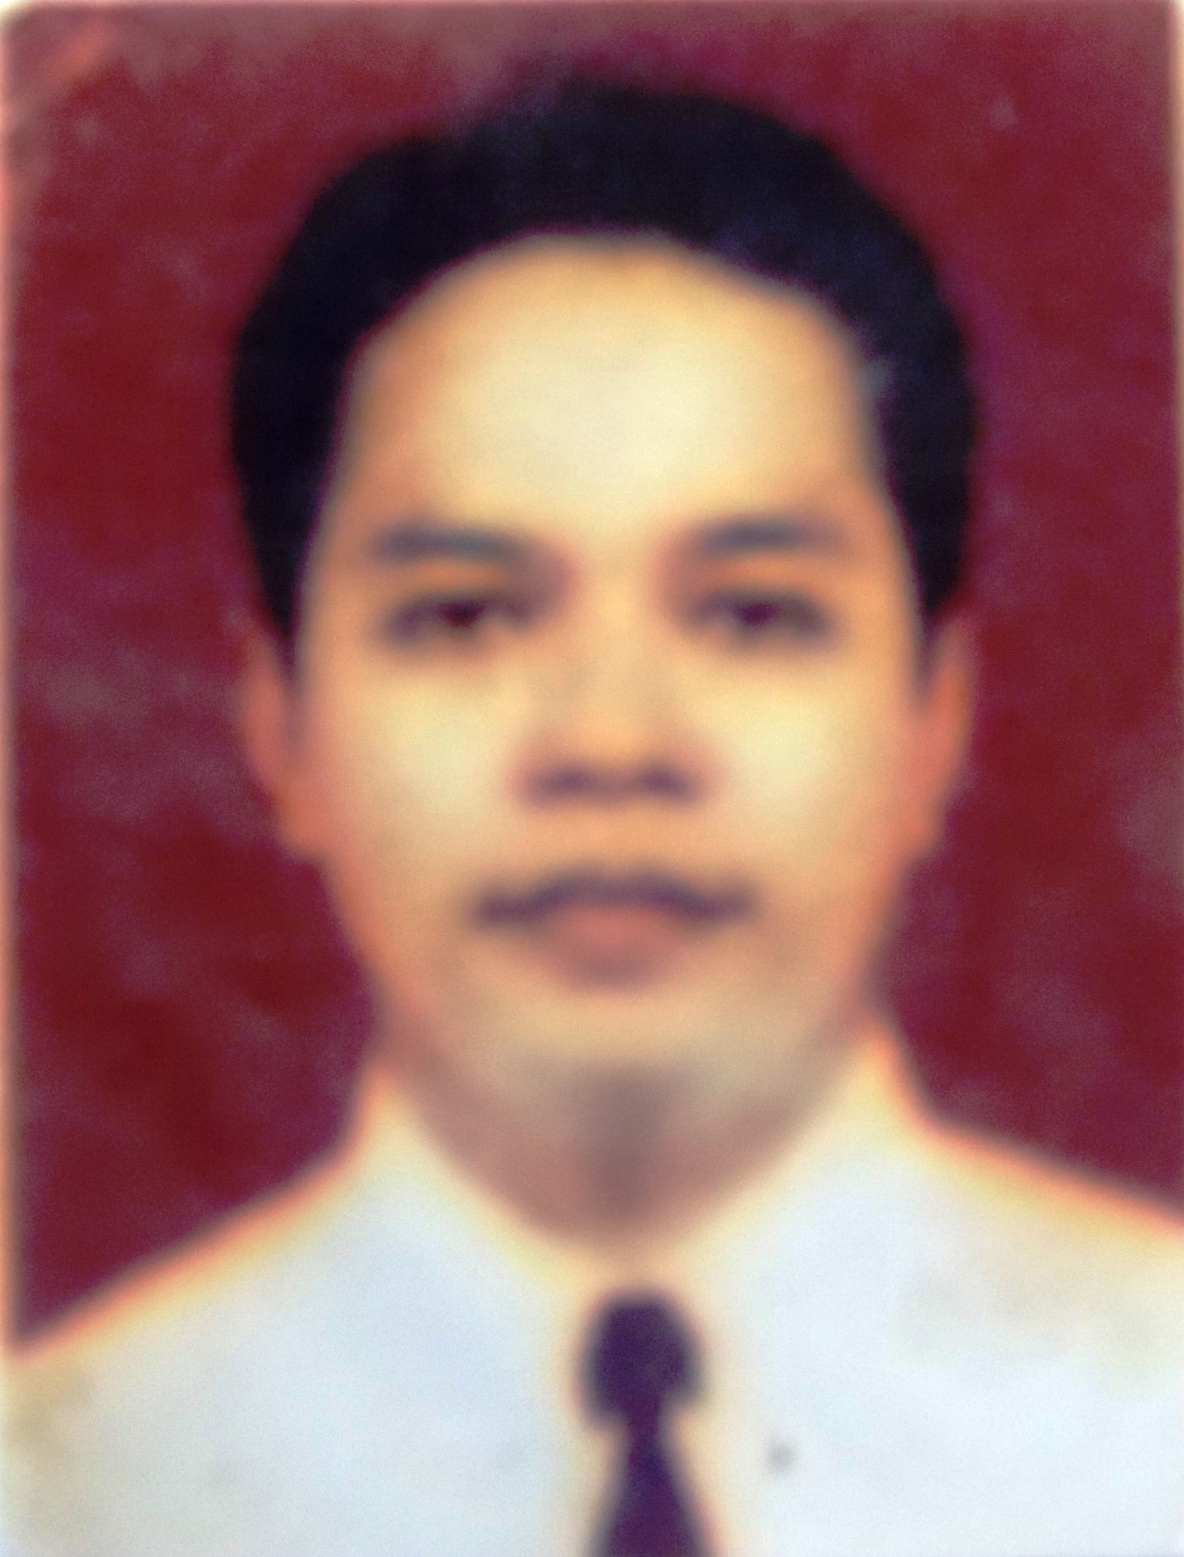

THE BOARD OF LIBRARY AND ARCHIVE OF YOGYAKARTA SPECIAL REGION

INDONESIA
2017

Statement Letter

Yogyakarta, July 10, 2017

By this letter I state:

Name | : Hendrikus Franz Josef, M.Si
Profession | : Librarian
Rank / Group | : Penata/ III c
Employee ID number | : 197508222005011009
Institution | : The Board of Library and Archive of Yogyakarta Special Region

States that this paper is my own work and does not contain plagiarism. Here is the results of anti plagiarism detection from www.smallseotools.com/plagiarism-checker, is 100% unique, which means there is no element of plagiarism.
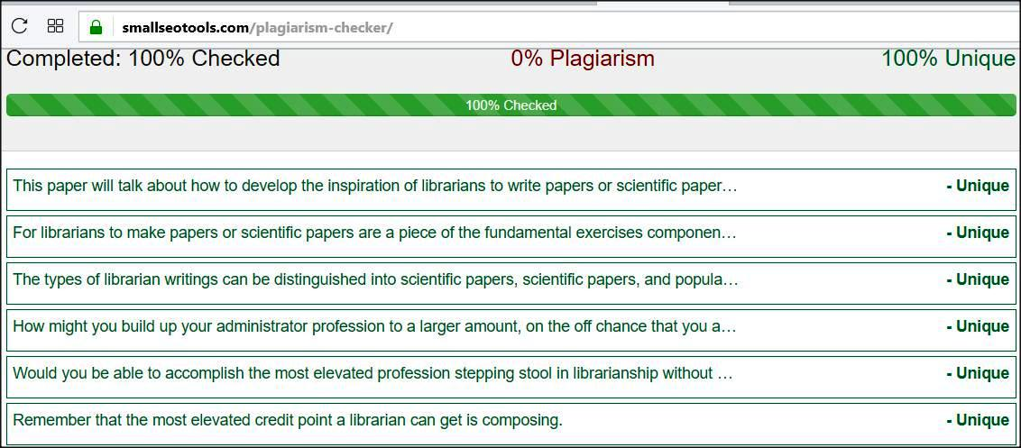

Thus I make this statement to be used properly.
Signed Author / Librarian
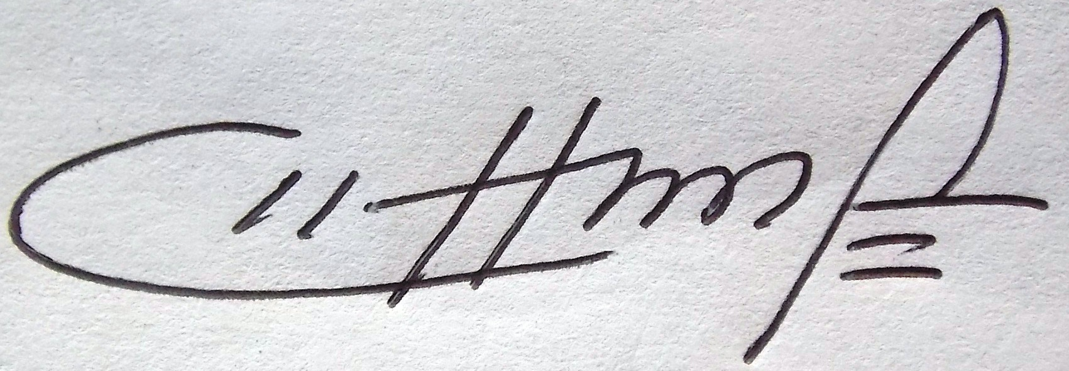
Hendrikus Franz Josef, M.Si
NIP. 197508222005011009

Abstract

This paper will talk about how to develop the inspiration of librarians to write papers or scientific papers. Inspiration composing is characterized as the motivation to write. To have the capacity to write required an ability. The capacity of librarians in composing can not be isolated by perusing exercises. For librarians to make papers or scientific papers are a piece of the fundamental exercises component of expert advancement and is one of the exercises that exist at all levels, both talented librarians and master level librarians. The amount of credit score for writing activities is greater when compared to the amount of credit score for other technical activities. The types of librarian writings can be distinguished into scientific papers, scientific papers, and popular scientific papers. Publications on librarianship in Indonesia, among others, can be a diary, magazine, announcement, or only a news sheet.
In the event that you are an expert administrator, at that point you are required to skillfully write, in light of the fact that written work aptitudes is a calling requests. How might you build up your administrator profession to a larger amount, on the off chance that you are not ready to write?. You are required to write letters, reports, papers, scientific articles, and different types of composing all through your custodian vocation. Would you be able to accomplish the most elevated profession stepping stool in librarianship without writing? As per the creator, the response to this inquiry is: Not conceivable. Since to accomplish the most abnormal amount of vocation or rank you need to accomplish, you require composed works for both expert advancement and advancement. Remember that the most elevated credit point a librarian can get is composing. The more librarians deliver writing in the field to the custodian, the less demanding it is to gather the credit focuses required for advancement.

Introduction

Composing movement is an innovative procedure. There are measurements of individuals, procedures and items. Somebody who does composing exercises, will pour thoughts or thoughts. The thought or thought can be acquired from the consideration of the life embraced and in addition from the aftereffects of perusing exercises. In this way composing is inventiveness. Inventiveness as indicated by Big Indonesian Dictionary (2008) is the capacity to make, create something because of the psyche. The consequences of a man's brain as a proof of innovativeness capacity, can be poured through composing, for example, articles, expositions, suppositions, scientific papers et cetera. Innovativeness in composing isn't a declining capacity, yet can be prepared continually, with the goal that somebody prevails with regards to having this capacity. The librarian calling, and also the instructor, scientist or other utilitarian officer is obliged to have what it takes/composing capacity. In the every day exercises related with the calling, they require this capacity, so assignments and obligations can be settled legitimately.

Regardless of whether we are a normal staff the real composition aptitudes are as yet required. In the work once in a while we are made a request to write movement reports et cetera. Maybe at first felt constrained to write, or even be required to figure out how to pour thoughts or submit movement reports. At last written work abilities will keep on being sharpened and effectively perform composing exercises, which is an imaginative procedure. The librarian's calling isn't just required to create reports of exercises, yet as per their useful positions, it is required to create callings, particularly to pour thoughts for library improvement. Subsequently, as indicated by the writer, the capacity of the librarian in composing is an unquestionable requirement, unavoidably, dislike, composing action should start. This is accentuated by Yusup (2013) who said that the authority of composing aptitudes involves worry to all of us.

Librarians in doing their calling are included and battling with data. Data one of which poured as a progression of words, numbers, sentences, which is then said as a data. This turns into a test and in addition open doors for librarians to be able to write. The expression "I can not write" is at times conveyed notwithstanding when they have not attempted, have not began to write. It should be supported from inside the self with the goal that a librarian will endeavor to do composing exercises. The most effective method to develop the drive from within course every individual is extraordinary. There are some who connect with librarians who happen to have more involvement in composing, or through perusing/book books identified with composing exercises, at that point urged enthusiasm to write. Once more, written work action is compulsory to be aced by a librarian.

CHAPTER I
Type of Scientifc Papers

The composition comprises or the like of, among others: scientific paper and the paper prevalent. Despite the kind of composing, there are really the most imperative thing that should be borne by the administrator, which is the initial phase in developing the inspiration composing. For another administrator begin composing, there is no compelling reason to write a scientific paper. In any case, can be begun from that level all the more effectively in particular famous paper. At that point on the theme and editorials can be from a standard action we do everyday in the library. For instance: accumulation handling, upkeep or gathering of library administrations.
Straightforward written work from the theme of the accumulation handling can be centered once more, for instance: preparing the gathering of books. The possibility of the composition can start with the procedure of stock the book, section what is composed, usefullness what, why need to top government offices, et cetera. Moreover the procedure of arrangement, Cataloging Rules et cetera can be straightforwardly composed as per what we do each day. The distinction here is that we are attempting to contend as the idea of the content/compositions. Beginning from here, at that point all dread the administrator about how to begin composing really can minimalize.
Composing exercises end up noticeably vital things that ought to be focused librarian, on the grounds that with composing can hone the knowledge of our cerebrum to ceaselessly pour thoughts. Likewise, with composing exercises will likewise be perceived how the nature of a bookkeeper. In this way by composing a librarian be tested to create themselves and won't again fasilities with his calling. The consideration of custodian works in the distribution of uncommon librarianship intermittently and the media day by day newspapers, at that point will influence the positive image from the calling of librarian. This will likewise influence how the point of convergence of the group and different experts to our calling
One of the attributes of scientific distribution in the field of librarianship is that the production contains articles composed by the librarian that outside specialists and involvement in the field of librarianship. Presently the kind of the paper is separated into 3, in particular:
1. Scientific Papers Based on Research.
The works that are sorted out by a librarian or a gathering of librarians who do look into/investigation and present the aftereffects of research. Typically composed with a standard organization that incorporates the dynamic presentation, materials and strategies results and dialog, the determination, and a rundown of the library. Illustration: examine report, errands end, unhitched male postulations, proposition, thesis, investigate paper inquire about examinations the aftereffects of the review appraisal and assessment in the field of librarianship.
2. Scientific Papers in View of the Thought.
The compositions or articles composed by a librarian or more which isn't gotten from the aftereffects of research or examination however from the thought or surveys the writing was scientific and composed in light of the standards of the scientific. Normally the arrangement of the written work does not have to take after the standard scientific paper. Case: proposition exercises, workshop papers, matter/lesson materials address, directing materials and transcripts of the scientific meeting in the field of librarianship.
3. Populer Scientific Papers.
Scientific work written in the regions of librarianship librarians and different fields, displayed in the compositions of well known and can be perused by the peruser or the overall population. Illustration: articles contained in the daily paper/every day daily paper.
To raise the inspiration to write, then let us look at the advantages that we will get, among others: 1. the thought/new thoughts will sharpen our mind to constantly innovative considering; 2. can be included the quantity of credit the rundown of the Proposed Credit Points drafting to expand the rank; 3. a separate appreciation, because there is a personal pride and satisfaction of mind; 4. There are normally some distribution that when the paper we stacked will get honorarium composing; 5. Can spur us to keep on developing themselves in following the improvement of the data all the more quickly.
The Librarian is a practical position with the goal that each of his work can be judged and increased in value by the quantity of credit. Other than that the librarian is likewise a calling in light of the fact that the need of mastery/abilities in the field of librarianship. The higher the authority useful, the charges against the satisfaction of various credit that originates from the components of the paper/distributed scientific papers will likewise be higher once more.
In the usage of the obligation librarianship some of the time we run over no practical authorities librarians who can't meet the credit numbers, in light of the fact that in the gathering of the quantity of credit all the more just depend on components of the exercises outside of the components of the advancement of the calling of the heaviness of credit little. Despite the fact that alongside that occasionally likewise caused by the librarian can't meet some of the quantity of credit required to increment larger amount positions.
When we look at, librarian appears to have not all do action which covers the primary components and supporting components. The marvel in the field regularly we see that the exercises did for proposing the Proposed Credit Points is still not as per the levels of the authority that had a place with the librarian. This can be realized that there are as yet numerous librarians who just focused on the specialized exercises just library, in particular sorting out and authoritative library material gathering/wellspring of data and advancement for the library documentation and data as it were. In the interim, there is so little to do the appraisal and improvement of librarianship and expert advancement. However we realize that one of the components of the exercises of the expert improvement on the best way to influence the paper/to paper in the field of librarianship scientific, the enormity of the estimation of the quantity of credit is high contrasted and the components of the other exercises.
As per my perception, there are at present a few things that reason the librarian has not yet delivered the paper/paper scientific meticulousness, among others: 1. most librarian timing out tersita just to practice day by day routine work that his tendency tedious. 2. perusing interest librarians who still low, causing the low write capacity. 3. The eagerness of librarian to create themselves less, and just happy with what he has improved the situation this. 4. The absence of librarian went to different preparing and direction composing strategy the paper/distributed scientific papers.5. librarians who feel 'regeneralize themselves' consider his calling has not been perceived in the public eye generally, so cause negativity if must contend and work together with other experts to write. 6. Lack of distribution productions about librarianship in Indonesia that suit the yearnings of librarian. 7. Components librarian instruction foundation formally or casually. 8. The absence of librarian in following the improvement of the data, with the goal that less reaction to the progressions. 9. absence of help from the bearing of components identified with inspire librarians to write. 10. The authority of an outside dialect that is still low with the goal that the librarian feel unfit to write particularly if must allude to foreign-language literature.

CHAPTER II
Writing and Publishing of Librarianship Theme

About librarianship publishing there are different sorts of any sort, among others can be diaries, magazines, bulletins, or essentially news sheet. As indicated by the writer is very different production in regards to library handle, documentation and data distributed in Indonesia it is sufficient. In any case, turns from the numerous distributions that have been distributed, swings to the quantity of the title not rises again and it isn't known how status additionally numerous. The field condition that regularly show up and turn into the base of the issue is frequently not the presence or absence of the content composition from the librarians who went into the table proofreader. There was likewise another hindrance that shows up, to be specific the restricted spending portion of assets for the cost of printing and production to other library. Therefore, the presence of these issues cause in the long run distribution which ought to suit the goals of the understudy librarians must be can't be distributed once more.
At the point when did this issue ought to be the librarian reflective look. Why publishing in the field of librarianship that we wrestled hello no our own particular compositions, what must hold up from other experts charge?. The librarian must make certain that with numerous compositions librarian that weighing and commendable dawn obviously will energize and help the development of publishing in the field of librarianship in Indonesia.
Read as knowledge to to write. To expand the window is to peruse. The capacity to write can't be isolated with perusing exercises. Prior to the librarian ready to write, then the librarian should read a ton. The point that perusing and composing can be educated and really should be possible by all librarian. So let us begin from now to attempt to write. Composing might be begun from the idea of what exercises we perform on an everyday in the library and advance what is related with the library to benefit clients. To construct the systems administration between the library and the sharing of data between the librarian, then the data contained in the library must be publicized and dispersed to the more extensive group as library advancement. Then can be produced more in level examination, for instance with the appraisal and scientific research in the field of librarianship.
Furthermore in regards to the intrigue write this, I think somewhat librarian has an intrigue that is sufficiently enormous to write. Just the base of the issue is how to begin?". At first positively appears to be troublesome and no weight. For instance: the title that isn't related with the substance of the thought isn't clear, between sections not related, word choices isn't right, not the concentration of the issue is analyzed, level of works between presentation, substance, and does not cover proposional, dialect use excessively broad, the utilization of the word that isn't steady isn't the crude materials, and others. This condition is normal, yet in the event that we continually attempt and many would practice we will be utilized lastly can write. This is in accordance with the aphorism that says "can because ordinary". The implication as the cutting edge isn't sharp but since honed consistently with great at long last sharp moreover.
Composing came back with numerous rectification or not stacked for different reasons from the editors are found. Librarians don't feel the agony because the scientific work we returned and corrected. Along these lines from here the start of our inspiration to proceed to enhance and make everything as material for feedback for our next article all together to improve things. There are a few hints for the librarian how to begin composing, among others: 1. The initial step is the point thoughts what shows up in our brain quickly pour as works, whatever it not an issue. 2. Write specifically and don't think other exercises, since we have no thoughts if not instantly composed will be rapidly lost, overlook, lastly stop. 3. On the off chance that all of a sudden feels halt, then make the layout which works as the projections of the street and the opening thoughts of what will we write. 4. Read focus and read back in over and over, alter the compositions that less exact word alternatives. 5. Erase the words that are seen to be more/not viable utilization of the sentence and include a terrified less. 6. Read more, comprehend and alter and alter again until the point that the compositions we are anything but difficult to peruse and effectively comprehended by others who read.
7. Keeping in mind the end goal to not confounded toward the starting when need to write, then "stay with your firearms", which means when we as of now have a subject that we trust great, we lean toward/preferred, and we can build up the point, then couldn't care less about the supposition of anybody. Specifically paper, paper, paper and write just thoughts we that shows up. 8. Build up a perusing society, figure out how to write and the capacity to write end up noticeably acclimated. 9. When we have been endeavoring to send to the editors, then don't give up on feedback. 10. Try not to influence composing exercises to appear to be a weight for us in working in the library. 11. Determine the objective time (dead line to have the capacity to finish the written work.

CONCLUSION

The capacity that is claimed by a librarian to write moment not simply happens. Moreover from the ability since conceived, yet additionally from the activity is ceaselessly, practical advancement and maintainable improvement (consistent change). Therefore, despite the fact that librarians don't have the ability when with practices self accustoms to write with myself, tolerance, strength, tenacious battle, diligent work without know tired and did not give up on specific librarians could write.
We as a librarian with the same common keeps the issuance of that entirely exists or never showed up in Indonesia all together not to not rises again simply because of the exemplary reasons that is the absence of supply of the paper/distributed scientific papers from librarians who go to the editors. I remind the librarian that don't just staying on the work that turned into the monotonous routine as it were. In any case, we as a librarian should likewise create themselves to do other exercises that help our calling, for instance by composing. Give us a chance to consider this expression " Writing is profitable for librarian".

BIBLIOGRAPHY

Gastel, Barbara, and Robert A. Day. How to write and publish a scientific paper. ABC-CLIO, 2016;

Sestak, Z. How to write a paper. Ed. George M. Hall. BMJ, 2003;

Santoso, Hari, and S. Sos. "Peningkatan keterampilan menulis karya ilmiah bagi pustakawan." Makalah didokumentasikan di UPT Perpustakaan Universitas Negeri Malang, (2007).

Santoso, Hari, and S. Sos. "Kompetensi Dasar Pustakawan dalam Menulis Karya Ilmiah." Malang: UPT Perpustakaan Universitas Negeri Malang (2011).

Wulandari, Tri, and Agus Setyo Utomo. "Motivasi Pustakawan dalam Menulis Karya Ilmiah pada Terbitan Berkala di Badan Arsip dan Perpustakaan Jawa Tengah." Jurnal Ilmu Perpustakaan 2.4 (2013).

