PAPERS

TITLE:

PROBLEMS AND CHALLENGES OF EBOOK PUBLISHING

WRITER:

HENDRIKUS FRANZ JOSEF, M.Si





THE BOARD OF LIBRARY AND ARCHIVE OF YOGYAKARTA SPECIAL REGION

INDONESIA
2017

Statement Letter

Yogyakarta, July 5, 2017

By this letter I state:

Name | : Hendrikus Franz Josef, M.Si
Profession | : Librarian
Rank / Group | : Penata/ III c
Employee ID number | : 197508222005011009
Institution | : The Board of Library and Archive of Yogyakarta Special Region

States that this paper is my own work and does not contain plagiarism. Here is the results of anti plagiarism detection from www.smallseotools.com/plagiarism-checker, is 100% unique, which means there is no element of plagiarism.
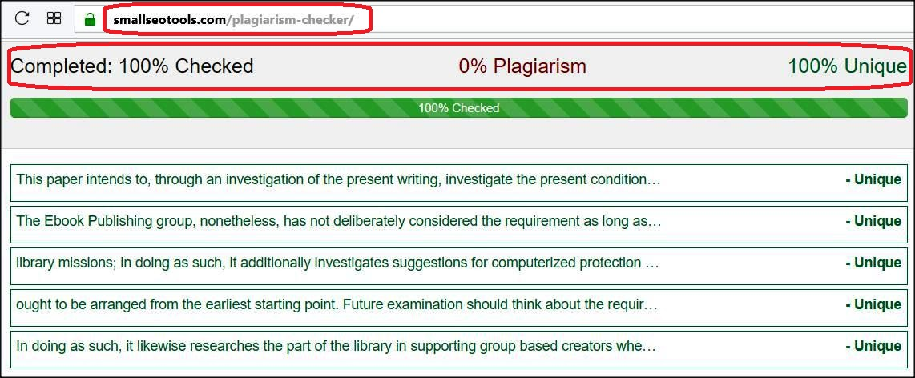

Thus I make this statement to be used properly.
Signed Author / Librarian
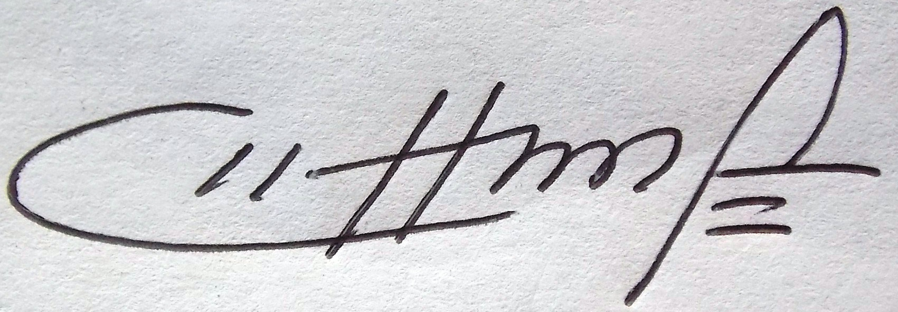
Hendrikus Franz Josef, M.Si
NIP. 197508222005011009

Abstract

This paper intends to, through an investigation of the present writing, investigate the present condition of the Ebook Publishing group and its way to deal with protection. Libraries are progressively proposing distributing administrations as a feature of their work with their groups, and as of late, there has been an articulated enthusiasm for giving electronic distributing (Ebook Publishing) administrations. The Ebook Publishing group, nonetheless, has not deliberately considered the requirement as long as possible conservation of the computerized content they help make. Outline/system/approach – Through a reﬂective investigation of the writing, this paper investigates the unique situation and the development of Ebook Publishing as a pattern that lines up with open library missions; in doing as such, it additionally investigates suggestions for computerized protection with regards to these new administrations and identifes holes in the writing. Discoveries – Digital protection is a critical and beneficial action for library ebook publisher; safeguarding of ommunity-based creator content can't, be that as it may, be a reconsideration and ought to be arranged from the earliest starting point. Future examination should think about the requirements and desires of group based creators. Existing advanced safeguarding rules additionally give a perspective to the group and analysts. Innovation-This paper addresses the understudied zone of the significance of advanced safeguarding to Ebook Publishing. In doing as such, it likewise researches the part of the library in supporting group based creators when Ebook Publishing through the library.

Introduction

Libraries are progressively proposing distributing administrations as a component of their work with their groups. As of late, there has likewise been an articulated enthusiasm for giving electronic distributing (Ebook Publishing) administrations. Ebook Publishing can possibly give a significant administration to group based creators, who, thusly, enhance the group through their work. By supporting e-distribution administrations, libraries are most certainly not just being dependable to their missions yet additionally attempting to give access to important material that, whatever the substance or approach, is an imperative and key piece of the social legacy of the group. This reasonable paper contends that the computerized safeguarding of novel, group based substance is likewise part of the mission of the library because of its enthusiasm for giving vote based access to content. However, social legacy content accessible in computerized groups is helpless and, consequently, must be a concentration of specific consideration.

The Ebook Publishing group has not deliberately tended to its part in the long haul protection of advanced substance that it makes. Exhaustive an investigation of the present writing, this examination shows the requirement for reﬂective and deliberate thought for computerized safeguarding in Ebook Publishing activities. We start by investigating the unique situation and the development of Ebook Publishing as a direction for the library; in doing as such, we additionally distinguish ramifications of these new administrations and holes in the writing. Next, we depict the need of computerized safeguarding, giving cases and distinguishing admonitions. After a discourse in view of the writing, we suggest both future strategies for libraries to take to shield e-distributed substance and future investigation to help that work.

CHAPTER I
EBOOK PUBLISHING TRENDS

Libraries have a mission to give access to data to their client groups. Since the rise of the World Wide Web, libraries have been tested by the high costs distributers are charging for electronic materials. In scholarly libraries, an "expanding part of a library accumulation is currently included authorized, not possessed, electronic materials". One late approach to elevate evenhanded access to a wide cross-segment of substance is for libraries to wind up distributers trying to control expenses and access. The 2013 Library Publishing Toolkit gives an accumulation of top to bottom parts for libraries intrigued by distributing. Since the turn of the thousand years, college libraries have fundamentally communicated an enthusiasm for independently publishing; open libraries, be that as it may, were frst inspired by independently publishing as ahead of schedule as the 1970s. In spite of the fact that vanity presses may have used the lethal hit to scholarly professions before , the expansive estimation of independently publishing is progressively being acknowledge.
As a contrasting option to customary distributing, independently publishing as appropriation or vanity presses has been dynamic for various years. Printing a keep running of books through vanity presses is a costly suggestion, in any case, and the Web now allows other, more affordable models for independently publishing. Creator administrations models, utilizing print on request, ended up noticeably famous in the mid 2000s and have given a scene to independent publishers to print littler keeps running of books effectively, enabling writers to "abstain from distributers in the conventional sense and turn into their own particular distributers", Much more efficient in advance are administrations like Amazon's Kindle Direct Publishing (https://kdp.amazon.com) where ebooks are distributed specifically to the Amazon Kindle Store and writers hold 70 for every penny of the eminences their books win.
These activities yield physical volumes that can be put away, under great conditions, for ages. Results of independently publishing have been by and large thought to be mediocre compared to generally distributed works because of the low nature of the substance and the specialty topic talked about. The independently publishing model does exclude some of the components of conventional distributing, and, for instance, would not really bolster creators in the creation or altering of their work or in its consequent promoting or dissemination. Though customary distributing vets creators, choosing just those with a demonstrated reputation and whose work is perceived to be of superb, independently publishing has a low boundary to get to. Independently publishing may, under a few conditions, resemble blogging or other Web-based distributing; the reason for the production, as per him, is the thing that has the effect.
However, calls for libraries to re-assess independently published works in view of their expanding achievement have been reverberated by those keen on the matter of specialty markets (Anderson, 2006). Bowkers' (2009) information show that 66% of books distributed were from nontraditional distributers and the 2011 information for 2010 showed that "The yield of non–customary titles was eight times as awesome as the quantity of standard distributed books" (Bradley et al., 2011). These numbers may demonstrate a potential diminishing of the independently publishing shame, or they may be characteristic of creators longing for the control that independently publishing manages them. As far as accumulations, independently published materials are being procured in libraries. School library media masters have additionally demonstrated their ability to see self as distributed materials for their accumulations (Glantz, 2013), at the same time, at introduce, this has had a tendency to infer physical duplicates.
Standard distributing models for the most part require that duplicates of a literary work be printed. With the approach of tablets and tablet PCs, be that as it may, getting to electronic books has turned out to be typical, as library offerings of ebooks bears witness to. Amazon and others have been advancing writer administrations for ebooks and other electronic assets. Library work in the digital book distributing zone stays new, with just a single area of the Ebook Publishing Toolkit (Brown, 2013) concentrating on the potential for Ebook Publishing.
Commitments to that area concentrate on a college e-press, depict workﬂows and models) and provide details regarding a pilot venture to make an ePub fle for the college's store in a scholastic library. However, offering Ebook Publishing administrations is a legitimate and possibly financially solid strategy for giving required distributing administrations to group based creators. Open libraries have been progressively advancing distributing as a sort of creator space benefit, permitting supporters the imagination to record "the story they have inside". For libraries to "Obtain the methods for e-content generation what's more, administration", opening the entryway for libraries to end up plainly enter accomplices in making digital book content. For quite a long time, libraries have been making ebooks accessible through Overdrive or NetLibrary, or ebrary, or different sellers. Adding independently published books to the blend truly isn't such an extend.
As open libraries hope to grow their administrations into Ebook Publishing, be that as it may, the discussion must swing to advanced protection. At introduce, it has not. Advanced substance can't be disregarded for drawn out stretches of time, as print can be and should be effectively overseen on the off chance that it stays available. Work in scholarly libraries on the theme of computerized conservation write vast has been finished by Li and Banach (2011) with Relationship of Research Libraries, part libraries in 2010. Around then, Li and Banach surveyed the condition of scholastic library conservation approaches and activities. A Ebook Publishing in librariesreview of the writing demonstrates that no comparable work has been finished researching advanced safeguarding in broad daylight libraries, particularly in light of their potential duty to group based creators through Ebook Publishing. Just a single part in the Ebook Publishing Toolkit tends to advanced protection. The significance of computerized safeguarding before portraying some ﬂavors of XML, yet given the short length of the part he can't talk about advanced protection inside and out. At exhibit, in this way, there has been no top to bottom evaluation of the topic of the computerized protection of electronic materials distributed by open libraries in spite of the basic that computerized protection.

Advanced substance is delicate– not at all like most paper, if not legitimately sorted out, oversaw and put away, it won't be retrievable or usable over the long haul. Advanced media is additionally delicate because of its dependence on innovation that can rapidly progress toward becoming outdated. Computerized protection as "a complete set of lifecycle administration and evaluation exercises to guarantee present and future utilization of advanced resources". Techniques for managing advanced protection are mind boggling, requiring more than reinforcements to secure the bits and bytes over the long haul. Advanced conservation includes a large group of confounded choices counting the determination of materials to safeguard, the specialized components to receive and the capacity to guarantee manageability of an undertaking through rights administration and financing.

Computerized safeguarding has been progressively perceived as a basic part of the administration of computerized content for the duration of its life cycle; yet, not all substance will essentially be held for protection. In a perfect world, signifcant things will be held and

protected after a keen choice has been made; bookkeepers should remember that "the choice not to spare one of a kind records is irreversible" Things identifed as having inborn esteem must be safeguarded. To encourage the advanced safeguarding of conceived computerized content, some of that work can and ought to incorporate work with chose creators and makers of substance to deliver precise metadata and to secure important rights. Moreover, advancing supportability through the determination of applicable, brilliant assets with enduring an incentive to a given group of clients should be a core interest.

Specialized choices will likewise should be made. To safeguard computerized content, three procedures can be received by libraries that apply to Ebook Publishing content – relocation, refreshment and imitating. Relocation alludes to moving computerized fles from one organization to a more up to date design. Refreshment includes duplicating information onto a more up to date stockpiling gadget of a similar sort (e.g. one hard drive to a more up to date hard drive). Last, copying alludes to the way toward guaranteeing that obsolete programming can be run for all intents and purposes on an alternate framework. In spite of the fact that these systems fluctuate, libraries that pick to give Ebook Publishing administrations must consider how they apply in their nearby setting, and also to the delicate advanced substance gave by creators on the off chance that they would like to adequately protect material over the long haul.

The instruments to protect are perplexing, yet a vigorous group of specialists and experts has examined the specialized, administrative and gathering based requirements to bolster the long haul advanced safeguarding of electronic substance, for example, ebooks. A abundance of national and global associations advancing computerized safeguarding exists and can be utilized as definitive assets for executing computerized protection. Cases of associations

that help bookkeepers and data experts with their work in computerized protection. In addition, the development of advanced curation as an umbrella teach "that incorporates computerized safeguarding, information curation, electronic records administration, and computerized resource administration" features the interconnected idea of computerized lifecycles with potential ramifcations for ebook publishing . On the off chance that advanced safeguarding isn't considered as a need in advance, ebooks composed by group based creators and distributed by libraries can't be accepted to remain available over the long haul in light of the fact that these three criteria for suffcient control won't have been arranged or met. Extra worries for manageability, including long haul subsidizing and bolster, will likewise be worries that libraries should consider yet for which no turn-key arrangement exists,

CHAPTER II

RULE AND MANAGEMENT OF EBOOK PUBLISHING

Basic reason was the want for control. Respondents needed to have the fnal say on the time span altering, outline, creation, dissemination, and promoting"; despite the fact that this look into was not specifc to Ebook Publishing, it is a decent establishment for investigating inspirations for grasping independently publishing models. At introduce, the topic of creator inspirations as far as control over rights fundamental for long haul computerized protection stays unanswered. Extra research investigations of library clients ought to likewise be conveyed out as libraries work to comprehend if copyright, organizations or interoperability worries on the piece of group based creators may unfavorably influence their capacity to safeguard content over the long haul.
Other work evaluating independently publishing creator inspirations has been generally narrative in nature. Some independently publishing model who needed the control that independently publishing at first advertised, at that point in this way re-distributed their books effectively with the Amazon Encore engrave. Built up creators may fnd creator administrations distributing models engaging on the off chance that they wish to take a stab at composing new classifications. Independently publishing creators are not by and large expert creators in charge of blockbuster deals; rather, he derives they keep their day employments and compose on the grounds that they need to compose, not for the cash. Disappointed with parts of the customary distributing industry, has likewise upheld independently publishing. At the point when creators distribute, they take an interest in the commercial center of thoughts. Because of the span of the distributing business and to limitations on the sorts of scholars that will be distributed, nearby voices may not be heard on the off chance that they select to depend on substantial national distributers.
Creator inspirations in the Ebook Publishing condition, be that as it may, remain understudied, as does information about open library clients' understanding about suggestions for the long haul safeguarding of ebooks. Open library clients, when reviewed on their own data administration works on concerning computerized safeguarding, "needed specifc learning with respect to which stockpiling gadgets/areas or fle positions were considered best to provide long haul access to computerized content". How best would public be able to libraries position themselves to serve the prompt needs of supporters wishing to independently publish while additionally supporting the requirement for advanced protection that their work speaks to?.
Ebook publishing have a commitment to assume liability for the advanced safeguarding of the substance they help with creating as a method for supporting their groups and elevating popularity based access to privately made substance. Scott (2011, p. 191) plots five ways that libraries manufacture groups by belligerence: (1) libraries fill in as a channel to get to data and to learn; (2) libraries empower social consideration and value; (3) libraries encourage city engagement; (4) libraries make a scaffold to assets and group association; and (5) libraries advance monetary essentialness inside the group. Mass-showcase distributions have verifiably ruled national markets immersing perusers with content from significant distributers.
While this substance might be of high caliber and, while little market distributers likewise exist, this approach isn't altogether with regards to popularity based esteems since it swarms out or rejects neighborhood voices. Vanity presses and creator benefits additionally have a tendency to be for-proft organizations which display another obstruction to distribution. Ebook Publishing offers a methods by which to defeat these difficulties by democratizing the distributing procedure in a way that obliges the necessities of neighborhood groups. In addition, doing as such likewise perfectly lines up with the beliefs as of now held onto by numerous libraries.
Mass-advertise distributing likewise tends to estrange groups and creators from their own work. As a result of the diffculty of being acknowledged by a noteworthy distributer, hardly any, productions are grabbed with respect to subjects of provincial intrigue. When they are, the procedure fundamentally expels the creator from generation, because of its substantial scale. Furthermore, obviously, most vanity distributers rather charge an expense showing yet another boundary to distribute. In either case, in any case, a writer's want to compose for composing's purpose, to control the production procedure, ensure distribution and to analysis won't be met. Those wishing to distribute are compelled to acknowledge these conditions and consequently will fnd themselves distanced from their work or essentially not ready to fnd their work in print.
Libraries, it appears, can void in the distributing market by offering independently publishing administrations to people who are disappointed with the distributing business yet at the same time need to distribute their work in some frame. At last, more research should be done in this region, however in view of this current article's examination, a progression of proposals, both hypothetical also, handy, can be made in help of open libraries wishing to investigate an Ebook Publishing administration while likewise saving substance.
Libraries are not the only one in considering unpublished works for consideration in their accumulations. Documents have been tending to related ideas for a considerable length of time in their work with special original copies. In spite of the fact that libraries are very much educated in accumulation improvement, library-distributed ebooks may not be as promptly assessed for choice as generally distributed materials.
As needs be, the chronicled idea of evaluation, a thought related with overseeing records, is a valuable and applicable idea to investigate in the Ebook Publishing setting. The subject of examination binds in to the evaluation of substance for computerized safeguarding since not all things can or ought to be spared. Determination, a related thought important for evaluation, is "the way toward choosing what things or assets will be added to a library's accumulation". Consolidated, examination and choice work will figure out which substance ought to be protected for use by the store's end-client and for to what extent.
This article fights that computerized safeguarding should be arranged in advance as Ebook Publishing activities are being investigated. Advanced protection is a continuous exertion, not a one-time concern. For it to be viable into the future, there should be progress contemplations for maintainability. In view of the survey of the writing, two essential maintainability related concerns are the accompanying: (1) the required framework in the library to deal with the innovation as far as HR and innovative assets; and (2) the privileges of group based creators. We investigate each underneath thusly, and afterward arrange the significance of computerized protection of e-productions inside the mission of the library.
Computerized safeguarding is intricate, and a one-estimate fts-all arrangement isn't accessible due to the uniqueness of every association, group of clients, staff and innovation. Albeit best practices have been created around a portion of the normal parts of computerized protection, including the choice of fle designs, different components remain unexplored or understudied. As library ebook publisher push ahead, they should consider issues of supportability that will drive both HR and innovative assets. Libraries should consider whether, for instance, they will charge an expense for Ebook Publishing activities. Expenses could settle future protection costs if the computerized objects are chosen to be kept up nearby, or could bolster outsourcing the advanced safeguarding to an outsider seller.
For long haul access to be guaranteed, group based creator rights should be secured. Best practices must be produced in the Ebook Publishing group that will allow creators to comprehend their rights and libraries to ensure and, if pertinent, share these works indefnitely. Rights allowing libraries to be stewards of the substance into the future should be secured at exhibit. Not just the capacity to relocate fle positions relies upon it yet in addition the capacity to utilize the substance. Metadata about the creator and the substance should be gathered from the creator as a major aspect of the distribution procedure as a method for guaranteeing recovery at a later point in time. The greater part of this, obviously, should be finished with deference for the group based creator and for the benefit of the group of clients as a main priority.
As an invitation to battle, this article implores upon custodians to consider important the protection basic for the duration of the life cycle of the computerized question yet in addition as an essential part of the Ebook Publishing activity they are working in help of their central goal. It challenges administrators to evaluate and assess content for long haul incorporation in their accumulations. Advanced safeguarding is a parallel activity, not an idea in retrospect, and it requires assets, framework and strategy to help its manageability. It is along these lines important to get ready for it from the earliest starting point.

CONCLUSION

All libraries should take steps to save privately made computerized content, including ebooks, as a feature of their main goal, and should make advanced protection a need when undertaking any Ebook Publishing activity. Because of their work with group based creators, open libraries have a specific commitment to save delicate computerized legacy content they help in making and in safeguarding content, as indicated by approaches, for sometime later. By advancing Ebook Publishing, libraries empower their groups to protect their legacy in extraordinary and credible ways. Both in principle and practically speaking, libraries should work to give safeguarding and access to special substance in light of group and client desires. Libraries are adapting to present circumstances of distributing, however when distributing electronic substance, mind must be taken to act capably. Libraries must consider not just the quick issues nearby, including mechanical and work force related, however they should likewise think about the gravity of their commitment to their creators and to their groups to contribute, lastingly, to the social record and the safeguarding of memory. Ebook Publishing in Digital Libraries conservation must be considered from the earliest starting point in any Ebook Publishing activity created by libraries, and cautious and orderly arranging in view of that work must take after.

BIBLIOGRAPHY

Ardiansyah, Ardiansyah. "Kajian Potensi e-Commerce Terhadap Industri Buku Digital Indonesia." (2012);

Connaway, Lynn Silipigni. "Electronic books (e-Books): Current trends and future directions." DESIDOC Journal of Library & Information Technology 23.1 (2003);

Hawkins, Donald T. "Electronic Books: A Major Publishing Revolution. Part 1: General Considerations and Issues." Online24.4 (2000);

Lee, Kyong-Ho, Nicholas Guttenberg, and Victor McCrary. "Standardization aspects of eBook content formats." Computer Standards & Interfaces 24.3 (2002);

Laquintano, Tim. "Sustained authorship: digital writing, self-publishing, and the Ebook." Written Communication 27.4 (2010);

Langer, Maria. iBooks Author: Publishing your first ebook. Flying M Productions, 2012;

Murray, Padmini Ray, and Claire Squires. "The digital publishing communications circuit." , 2013;

Stork, Paul Papanek. "eBook Publishing: Standards and Technologies." New Raiders (2000);

Tian, Xuemei, and Bill Martin. "Impacting forces on ebook business models development." Publishing research quarterly 27.3, (2011).

