PAPERS

TITLE:

THE DEVELOPMENT OF THE RIGHT TARGET LIBRARY COLLECTION FOR SPECIAL READERS

WRITER:

HENDRIKUS FRANZ JOSEF, M.Si





THE BOARED OF LIBRARY AND ARECHIVE OF YOGYAKARETA SPECIAL REGION

INDONESIA
2017

Statement Letter

Yogyakareta, 24, 2017

By this letter I state:

Name | : Hendrikus Franz Josef, M.Si
Profession | : Librareian
Rank / Group | : Penata/ III c
Employee ID number | : 197508222005011009
Institution | : The Boared of Library and Arechive of Yogyakareta Special Region,  Indonesia
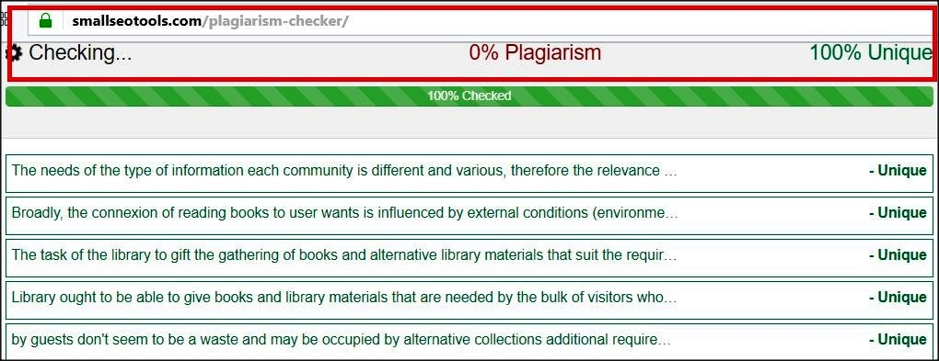

States that this paper is my own work and does not contain plagiareism. Here is the results of anti plagiareism detection from www.smallseotools.com/plagiareism-checker, is 100% unique, which means there is no element of plagiareism.

Thus I make this statement to be used properly.
Signed Author / Librareian
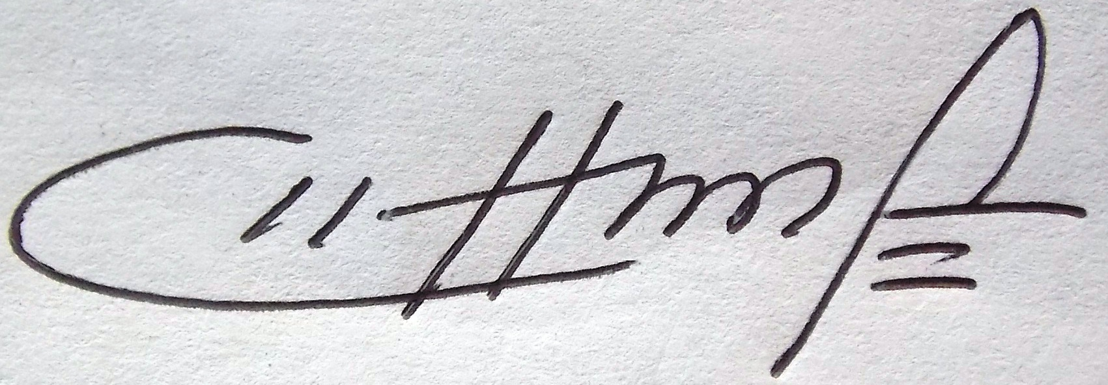
Hendrikus Franz Josef, M.Si
NIP. 197508222005011009

Abstract

The needs of the type of information each community is different and various, therefore the relevance of associate degree information for an individual is powerfully influenced by the particulate scenario in him. Understanding the kinds of knowledge library users want is extremely vital and this becomes the idea of thought in choosing library materials for the needs of library development. Broadly, the connexion of reading books to user wants is influenced by external conditions (environmental circumstances), admire general insight; socio-cultural conditions; economic potential and natural resources; geographical and environmental conditions; and internal conditions (personal users) admire the psychological dynamics that are littered with the age of the user. The task of the library to gift the gathering of books and alternative library materials that suit the requirements of users or guests. During this case the library doesn't essentially have to be compelled to give and present the library collections as complete as possible. Library ought to be able to give books and library materials that are needed by the bulk of visitors who return particularly for library that are during a specific establishment or library that encompasses a special theme. It aims to create the library work effectively. Library ought to be able to minimize the supply of library materials that don't seem to be required by visitors in order that library materials that are never employed by guests don't seem to be a waste and may be occupied by alternative collections additional required users. What's vital to notice is the way to determine the appropriate library collection for readers and attract the need of visitors to read.

Introduction

The library, both convensional and digital, were established to satisfy the data wants of its users. The linkage between data within the library collections offered with the required data has a terribly very important role. the upper the extent of fulfillment of those wants, the upper the worth of use or advantage of a library. the event of technology and culture at this point demands the event of library collections, each in terms of the quantity of collections and media decisions. changes in terms of content content are within the selection of tension between meeting the most recent technological developments and therefore the got to apply the richness of existing traditions and living in society to avoid extinction. Another problem, pareticularely between the role of librareies to encourage economic improvement of the individuals and interests to keep up the balance of nature.

The choice of media and sources is overwhelming, along side the advancement of existing digital technology. However, the utilization of the most recent data technology needs careeful budget calculation as a result of it should give funds for supporting infrastructure and human resource capabilities that manage. The type of data individuals would like is extremely vareious. The connectedness of an data to someone is powerfully influenced by the pareticulare state of his / her own. additionally to fulfilling curiosity, the data consumed by someone aims to resolve issues and desires in life, pareticularely those who are important and pressing. For example, fashion product data for a teenager is additional relevant than data concerning the ins and outs of hearet condition.

For teenagers, up-to-date fashion data is extremely vital in association, and therefore will sustain existence among alternative teenagers. Conversely, the ins ANd outs of handling acid within the body for an senior is clearely additional wanted than data concerning attracting the other sex. In alternative words, another age of interest. Understanding the categories of data library users would like is thus important. This becomes the idea of thought in choosing library collections for library development functions. Broadly speaking, the relevance of reading books to user wants is influenced by external conditions (environmental circumstances) and internal conditions (personal users).

Chapter I

Consideration in Developing the Library Collection

Each sort of library serves a bunch of users with certain characteristics, so careful designing is needed, what services ar acceptable to the requirements of the library user. the look are going to be sure-fire if supported a sufficiently deep information of the communities to be served. The term utilized in this study is that the analysis of user desires (needs analysis). This user desires analysis is extremely helpful however it's long and expensive. It needs careful designing by obtaining who is doing the analysis, what data is required, what technique is used in information assortment, and for what information is used.
The development of collections may be a dynamic method to satisfy the data desires of the library user community quickly and economically, by utilizing the sources of knowledge created among and outdoors the organization. There area unit vi (six) stages that has got to be done by the library / professional manager, this stage may be a method that takes place endlessly and kind a hard and fast cycle. The six stages are: community analysis; choice policy; choice of library materials (selection); procurement of library materials (acquisition); weeding; and analysis. In carrying out every of the higher than stages, library managers must always concentrate to who becomes a community served (patron community).
1). Establish the community served (Community analysis). User teams with sure characteristics, area unit users of varied styles of libraries, steady designing, what services area unit acceptable to those users area unit indispensable. In understanding the wants of this community there area unit many terms that area unit typically used resembling community analysis, desires analysis (needs analysis), user reviews (user's studies), etc. In conducting the analysis of the community, it ought to be noted all the variables that have an effect on the library services to the community. All printed knowledge (books, statistics, sociology, history, etc .. additionally needed supporting knowledge that may be obtained through interviews and questionnaires. 2). choice policies. Policies within the development of the collection, contains an inspiration or action used as a book of facts within the library. These policies area unit required particularly once deciding what subjects to shop for and the way several subjects every receive material, in addition as budgeting for every subject. 3). choice of materials (selection). Namely the activities of libraries / data centers to pick out library materials, choice activities is associate activity that's important within the development of collections. The success of the library is essentially determined by the supply of collections each quantitatively and qualitatively. therefore the library collection ought to still be nurtured with preciseness and accuracy. 4). procural (acquisition). Procurement features a terribly wide understanding not solely purchase or order, however includes things that require to be done when the choice of books, that include: a) Acquisition of the book, through: Purchase, Prize, Exchange, b) Payment / payment receipt, c) Prepare records with reference to the procural of library collections. 5). Weeding. Weeding may be a library activity for the availability of library materials contained within the library assortment as a result of the collection is broken, seldom used, and isn't any longer used, and since of legal or regulative factors. 6). analysis (evaluation). Evaluation is completed to grasp the map of strengths and weaknesses of the collection. This analysis activity is helpful for understanding the effectiveness of the collection for the users and can also know the budget every year that is helpful for the filing of budget / fund for the next year.
External Condition issues for determine the process of developing a library collection, are: 1). General insights. General insights or knowledge includes things that the users would like or need to grasp from numerous circles. the newest news in newspapers or magazines, language dictionaries or language dictionaries, public encyclopedias or special encyclopedias, may be classified as general insights. This assortment ought to be well-kept so far and obtainable the least bit times, creating it potential to be a reference that may not be borrowed and may be browse on the spot. Different types of dictionaries and encyclopedias area unit currently obtainable in digital formats, appreciate Microsoft Encarta, cyclopedia Britannica, and college textbooks. If a library is obtainable on a pc, it should be a lot of fun if a reference is obtainable during this digital format, particularly once an online affiliation is obtainable.
2). Socio-cultural conditions. Libraries will participate within the effort to introduce, protect, and develop the culture of the regions in land. Cultural diversity in land is extremely high compared to different countries generally. land has one,128 tribes, every tribe has language, art, ancient ceremonies, and different distinctive cultural artifacts because the inheritance of the ancestors. Showcasing attractions and ancient cultural artifacts is physically troublesome the least bit times. Therefore, the literature provided within the library will represent the existence while not essentially reducing its informative price. Literature may also be used as a medium of introduction to tykes or guests who need to get native cultural data.
The cases of cultural heritage claims against Asian nation created a while past (and terribly doubtless to happen again) arouse our awareness of the importance of inventory efforts of our cultural assets. within the college course of study, native cultural introduction material is quickly obtainable. However, a full and complete study wouldn't be potential to gift all of them during a restricted course of study. native governments have to be compelled to admit documenting their own cultural assets and cultural activities thus on facilitate management and avoid threats of extinction.
3). Economic potential and natural resources. Libraries will facilitate communities in a trial to boost people's lives by providing the mandatory data in their daily economic activities for his or her users. The economic and natural resources potential ought to even be thought-about during this library development effort. additionally to various socio-cultural aspects, the economic potential of every region is additionally completely different. This distinction isn't perpetually an equivalent as body boundaries. to Illustrate, an agricultural society actually needs data concerning agriculture. Relevant data for them is agricultural data from upstream to downstream, to Illustrate, seed breeding, crop maintenance, gadfly management, to gather and promoting.
Other supporting sides such as data of plant varieties, climate suitableness, suitableness of soil conditions, and increasing added efforts of commodities, may be informative price necessary to farmers. Similar applications may be drained different areas of various designs. Coastal areas, areas adjacent to forests, holidaymaker villages, crafts communities and inventive communities, may be found in land. every sort of business needs the support of information typical of the sphere to support productivity additionally to direct coaching job from connected establishments.
It is additionally necessary to suppose that these economic activities do not change into the pressures of interest that threaten the preservation of the surroundings. presently a great deal of economic activities that have an adverse impact on the surroundings. Thus, the socialization of information provided by libraries relating to the economic field has 2 interests, namely, increasing people's economic revenues and preventing the threat of environmental destruction.
4). Geographical conditions and environmental conditions. Environmental injury isn't solely caused by human activities however may also flow from to natural factors that area unit natural. This natural injury will occur in such a harmful sort of natural disaster that threatens the lives of the inhabitants. Efforts to minimize the chance of natural disasters may be done through data dissemination or dissemination within the library. This effort includes into anticipation or patterning of the countermeasures of disaster before the potential of existing disasters truly occur.

Chapter II
Objectives and Functions of Library Collection Development

Developing library collections (Library assortment development) is an attempt to enhance the standard of library services through the supply of spare and library materials in accordance with the necessities of readers. The library may be a role of the intermediary that bring together between the requirements of users with collections that square measure out there within the library. This suggests that the library is an establishment that collect between the two readers, that is, as data seekers with author data through works he wrote. Verily, the Library ought to be ready to save cultural treasures of nations or communities wherever the library is found and conjointly increasing the worth and appreciation of the culture of the local people through the method of providing reading materials (Wiji Suwarno: 2007; 15).
Next library as data system with services of storing information in numerous varieties of documents further because the settings square measure specified the required assortment of knowledge are often recovered quickly and exactly. A benchmark of success library is that the ability to produce sources of knowledge required by the user. The event of library collections is enforced so a set of endlessly follow the event of renewable science, for it absolutely was then the event of the gathering of the library should be performed frequently and hard-wired so collections square measure continually Up to now (acceptable development time or times). With a set that's continually up to now then it is hoped the library would still demand by readers.
Information desires readers square measure continually evolving in line with the stress of the development of science and technology, further as changes within the pattern of community life within the search of knowledge and authorization to fulfill the wants of life and profession or her work. Development of collections is that the responsibility of the supplier of the library, that ought to concentrate to a range of things: (1) the aim of the library on coaching (2) data desires for readers (3) accessibility of funds (4) Science (subject Variants five assortment Type) (6) the quantity of Collections (7) (8) quality of publication etc. within the broader context, the development of the collection also involves the complete stakeholders (Stake holders), readers (user), the government (as party funder), community, publishers, suppliers, and management.
To be ready to perform the task well, assortment development Manager library establishments ought to perceive the varied matters concerning the development of collection, (1) the principles of assortment development of library materials, such as destination development of collection, (2) collection development principles, (3) development of procedures or mechanisms of assortment, further as (4) policy cares with the event of the library.
In the giant Indonesian Language dictionary (Ministry of national education, 2005; 10) mean that the signified the book readers. And therefore the references says that the library could be an assortment of libraries, whether or not within the type of books, comparable to newspapers, magazines, maps, brochures, and so on. Development of assortment (Collection Development) is one among st the areas of library and management info sources that are usually illustrious. Assortment development came about within the early stages of a sequence of activities the library and wont to develop and build the library assortment or set of materials required to fulfill the requirements of the readers data. Definitively, the understanding of the event of the library's collections embody all activities to expand the present collections within the library, particularly related with the election activities are associate degree analysis, moreover because the acquisition of library materials. This activity is sometimes contained within the assortment development program whose contents vary between one library with another library. A distinction that affected variety of things, comparable to government policies, economic conditions touching policy against funding, readers habits, attitudes and native conditions. In Act No. forty-three of the year 2007 article twelve paragraph (1) of the library's collections are hand-picked, processed, stored, administered and developed in accordance with the interests of the readers attentively to the event of knowledge and communication technology. And additional described in article twenty-five that exact Library ought to give the fabric library in accordance with the requirements of the readers in its atmosphere.
If seen farther, that the event of library collections is a component of the intensive activities specifically the gathering management policy includes the event of collections, the library material value allocation, selection, analysis, studies assortment use of assortments and users collection (readers), coaching and organizing staff development library assortment. Some definitions of development of library collections, it is understood that the event of assortments is actually an effort to develop the library's collections through a procedure has been attack the idea of policy development the present collection so as to produce sources of knowledge (reading material) that's complete, up so far and usefull for readers. Alternative business development assortment or references is obtained by suggests that of: (1) purchase; (2) a present or donation; (3) Exchange; (4) Borrow, rent, and repeating (Ibrahim Bafadal, 2005:31-33).
Collection Development perform is as follows: (1) increase the amount library collections, in order that collections and balanced within the subject, sort and variant forms, furthermore as its format to full fill the wants of data for readers; (2) improve the standard of the library's collections each in terms of the accuracy of the knowledge content of the novelty of the topic, furthermore as compliance with the knowledge wants of the wearer; (3) make sure that the library's collections area unit perpetually up to this point thus fastened interest readers. So the expected presence library.
Types of library assortment consists of some style of type, format, or content and the way to serve, which may be distinguished from the assorted facets: (1) in terms of packaging, there square measure references (printed) written and non written (Non printed); (2) References, there's a written references (printed) consists of: books, magazines, journals, bulletin, pamphlet, brochure, newspaper clippings, and others. Packaging written collection additionally varied Tiger-quality. Some uses paper of luxury, there square measure paper, paper and a few square measure hardcover paperback. Non print library collection consists of: CD-ROM, tapes, rolls of film, slides, digital files, forms, audio visual, e-book, and others. In terms of library services there's a sort of public collections and a group of reference: (a) the overall collection, may be a collection that contains the science in a very sort of disciplines.

The contents square measure sometimes extended and in-depth descriptions a couple of specific subject. Differing kinds as follows: (1) the shape of the sort of text book, that book is obligatory for a specific subject that's set supported the curriculum; (2) accessory Books, i.e. books that enrichment has a recommendation from the govt. to be used in school/college; (3) varieties of books of fiction and non-fiction will stimulate talent and a passion for readers; fashionable books, i.e. books that the contents of the popular General Science; (4) results of analysis books, particularly the kind of assortment of books that square measure sometimes administered to read in places, on loan, and may be copied. (b) assortment of the particular reference, additionally formed sort of book, with a book that distinguishes public collections such as the higher than is and the way the presentation of the contents. The contents of the reference books sometimes is data that is prime and authoritative reference. The reference assortment consists of dictionaries, encyclopedias, yearbooks, manuals, user guide, biobliography, supply biographies, directories, smart book, handbook, reference assortment, inform products square measure generally administered by method of a scan on the spot or copied, not loaned to take home.
Viewed from the context of the library as data systems development collection may be a sub-system of input, i.e. a stage early in organizing the library before the process activities and services. However, library that has been running the event of collections is an activity that has got to be performed often and hard-wired continuously. Will annually, per semester, or quicker once more quarterly, monthly or perhaps at any time.
The scope of {the collection|the gathering} development includes all activities that square measure orientedto the development of the standard and quantity of the library's collections that include: (a) Policy development collection. This policy is that the basis for designing the event of the gathering. This policy was created to produce clear direction to the event of collections in order that the gathering is developed a lot of directional and a lot of balanced, each in terms of the kind, form, subject data, language. Basis of preparation of the gathering development policy is an objective data regarding the aim of education and training wherever the library is found, the aim of the library, books involving eye training was taught. curriculum, and readers or the users of the library.
With the data that the Manager will arrange the event of library collection the library materials square measure directional and a lot of helpful to support the accomplishment of the objectives of education and training; (b) the choice, i.e. the activities of the election and verify the kind, quality and amount of the materials libraries to be command. The choice is finished by the one who manages the library in cooperation with the Chairman, or of the teaching material or concepts from readers; (c) procedural of Library Materials, i.e. a step beyond the choice. Procedural is an activity that refers to the procedures when the election activities to accumulate materials for the library; (d) Weeding References (;), that is one among the activities of the care of collections by approach of provision library materials or withdraw from the gathering of unused and add a group which will be required with the aim of keeping the freshness and power to the library's collections.
Development of special library collection at intervals the employment Hall aims: (1) hold a group of libraries unit of measurement enforced programmatically and programmed properly, routine and steady; (2) Holds a group of relefant for readers in step together with your desires or the user, that the prevailing assortment of underutilized; (3) hold a group of quality and continuously follow the event of Science (Up to date), so the assortment is typically actual and interest browse the wearer; (4) hold {a assortment|a set|a group} development policy with regard to the gathering that is clearly that the succeeding collection of higher quality or quality, balanced at intervals the topic, type, vary of copies and conjointly the date, that the gathering can support the action of the objectives of education and training (training and education); (5) Providing correct references at the time of the library materials needed; (6) providing access to a wider information for users.

CONCLUSION

The development of the collection of the library had a very strategic role in fostering and foster charm and awareness for reading. Reading activities could not be free from the existence and convenience of reading materials within the library are adequate, each in quantity and in quality of the readings. Some things to notice within the development of the collection of references: (1) select a book or library materials tailored to the wants and demand of readers furthermore as tailored to the aim and performance of the library; (2) books that are chosen ought to be provided to any or all.
So the development of collections is a crucial consider order to be ready to meet the stress of a library data wants. Date collection and satisfy data wants is that the attraction additionally to boost the image and quality of service. Development of assortments is that the whole activities to expand the prevailing collection within the library. Collection policy ought to be adjusted to satisfy the wants of information users timely and applicable. Collection development activities embody choice, and maintenance. Library collections ought to be created from a systematic and purposeful choice tailored to the goals, plans, and budgets accessible.

BIBLIOGRAPHY

Brod, Shirley. What Non-Readers or Beginning Readers Need To Know: Performance-Based ESL Adult Literacy. Spring Institute for International Studies, 1610 Emerson Street, Denver, CO 80218, 1999.

Evans, G. E. Developing Library and Information Center Collections. Library Science Text Series. Libraries Unlimited, Inc., PO Box 6633, Englewood, CO 80155-6633, 1995;

Ibrahim, Bafadal, Pengelolaan Perpustakaan Sekolah, Jakarta: Bumi Aksara, 2005;

Kamus Besar Bahasa Indonesia (KBBI), Tim Penyusun Kamus Pusat Pembinaan dan Pengembangan Bahasa, Jakarta Balai Pustaka, 2005;

Moskowitz, Mickey. "Collection development and the college library: a state-of-the-art review." Collection Building 6.2, 1984;

Undang-Undang Republik Indonesia Nomor 43 Tahun 2007 Tentang Perpustakaan, Jakarta, Perpustakaan Nasional Republik Indonesia, 2007;

Saricks, Joyce G., Readers' advisory service in the public library. American Library Association, 2005;

Wiji Suwarno, 2007, Dasar-dasar Ilmu Perpustakaan: Sebuah Pendekatan Praktis, Yogyakarta, Ar-Ruzz, 2007.

